MODULE-3
Exercise 1: Ranking and Window Functions :
Goal: Use ROW_NUMBER(), RANK(), DENSE_RANK(), OVER(), and PARTITION BY.
Step 1: Create Database
CREATE DATABASE OnlineRetailStore;
USE OnlineRetailStore;
Step 2: Create Products Table
CREATE TABLE Products (
ProductID INT PRIMARY KEY,
ProductName VARCHAR(100),
Category VARCHAR(50),
Price DECIMAL(10,2)
);
Step 3: Insert Sample Data
INSERT INTO Products VALUES
(1, 'Laptop', 'Electronics', 80000),
(2, 'Smartphone', 'Electronics', 60000),
(3, 'Tablet', 'Electronics', 40000),
(4, 'Headphones', 'Electronics', 10000),
(5, 'TV', 'Electronics', 80000),

(6, 'Sofa', 'Furniture', 50000),
(7, 'Dining Table', 'Furniture', 45000),
(8, 'Chair', 'Furniture', 10000),
(9, 'Bed', 'Furniture', 50000),
(10, 'Cupboard', 'Furniture', 30000),

(11, 'Shirt', 'Fashion', 2000),
(12, 'Jeans', 'Fashion', 3000),
(13, 'Jacket', 'Fashion', 5000),
(14, 'Shoes', 'Fashion', 4000),
(15, 'Watch', 'Fashion', 5000);
Step 4: Verify Data
SELECT * FROM Products;
OUTPUT:
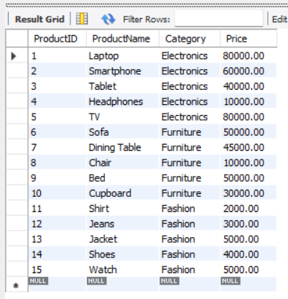
Step 5: ROW_NUMBER()
SELECT *
FROM (
SELECT ProductID,
ProductName,
Category,
Price,
ROW_NUMBER() OVER(
PARTITION BY Category
ORDER BY Price DESC
) AS RowNum
FROM Products
) AS Ranked
WHERE RowNum <= 3;
OUTPUT:
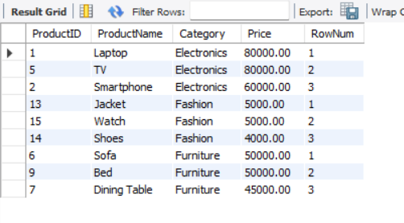
Step 6: RANK()
SELECT *
FROM (
SELECT ProductID,
ProductName,
Category,
Price,
RANK() OVER(
PARTITION BY Category
ORDER BY Price DESC
) AS RankNum
FROM Products
) AS Ranked
WHERE RankNum <= 3;
OUTPUT:
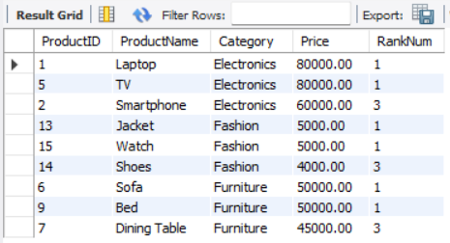
Step 7: DENSE_RANK()
SELECT *
FROM (
SELECT ProductID,
ProductName,
Category,
Price,
DENSE_RANK() OVER(
PARTITION BY Category
ORDER BY Price DESC
) AS DenseRankNum
FROM Products
) AS Ranked
WHERE DenseRankNum <= 3;
OUTPUT:
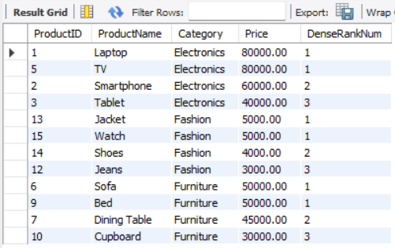

SQL Exercise - Stored procedure
Exercise 1: Create a Stored Procedure
Goal: Create a stored procedure to retrieve employee details by department.
Step 1: Create Database
CREATE DATABASE EmployeeManagement;
USE EmployeeManagement;
Step 2: Create Departments Table
CREATE TABLE Departments (
DepartmentID INT PRIMARY KEY,
DepartmentName VARCHAR(100)
);
Step 3: Create Employees Table
CREATE TABLE Employees (
EmployeeID INT AUTO_INCREMENT PRIMARY KEY,
FirstName VARCHAR(50),
LastName VARCHAR(50),
DepartmentID INT,
Salary DECIMAL(10,2),
JoinDate DATE,
FOREIGN KEY (DepartmentID) REFERENCES Departments(DepartmentID)
);
Step 4: Insert Sample Data
Departments
INSERT INTO Departments VALUES
(1, 'HR'),
(2, 'Finance'),
(3, 'IT'),
(4, 'Marketing');
SELECT * FROM Departments;

OUTPUT:
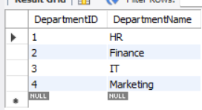
Employees
INSERT INTO Employees
(EmployeeID, FirstName, LastName, DepartmentID, Salary, JoinDate)
VALUES
(1, 'John', 'Doe', 1, 5000.00, '2020-01-15'),
(2, 'Jane', 'Smith', 2, 6000.00, '2019-03-22'),
(3, 'Michael', 'Johnson', 3, 7000.00, '2018-07-30'),
(4, 'Emily', 'Davis', 4, 5500.00, '2021-11-05');
SELECT * FROM Employees;
OUTPUT:
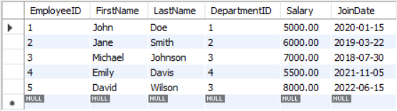
Step 5: Stored Procedure to Retrieve Employees by Department
DELIMITER //
CREATE PROCEDURE GetEmployeesByDepartment(
IN DeptID INT
)
BEGIN
SELECT *
FROM Employees
WHERE DepartmentID = DeptID;
END //
DELIMITER ;
CALL GetEmployeesByDepartment(3);
OUTPUT:
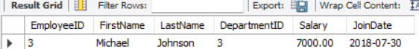

Step 6: Create sp_InsertEmployee
DELIMITER //
CREATE PROCEDURE sp_InsertEmployee(
IN p_FirstName VARCHAR(50),
IN p_LastName VARCHAR(50),
IN p_DepartmentID INT,
IN p_Salary DECIMAL(10,2),
IN p_JoinDate DATE
)
BEGIN
INSERT INTO Employees(FirstName, LastName, DepartmentID, Salary, JoinDate)
VALUES (p_FirstName, p_LastName, p_DepartmentID, p_Salary, p_JoinDate);
END //
DELIMITER ;
CALL sp_InsertEmployee(
'David',
'Wilson',
3,
8000.00,
'2022-06-15'
);
OUTPUT:

SELECT * FROM Employees;
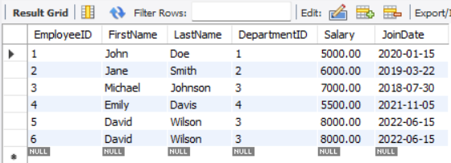

Exercise 5: Return Data from a Stored Procedure
Step 1: Create Procedure
DELIMITER //
CREATE PROCEDURE GetEmployeeCountByDepartment(
IN DeptID INT
)
BEGIN
SELECT COUNT(*) AS TotalEmployees
FROM Employees
WHERE DepartmentID = DeptID;
END //
DELIMITER ;
Step 2: Procedure execution
CALL GetEmployeeCountByDepartment(3);
OUTPUT:

